CSCE2114 Digital Design
Lab 3 – Part 1

During this lab you will construct a multiple circuits and document their operation. The ICs available are the 7400, 7402, 7404, 7408, 7410, 7411, 7427, and the 7432 (though the problem statement may restrict what chips you may use). You will construct each design using the PB-505 trainer. The lab problem statements as well as a diagram of each IC are shown below.
- Implement F(A,B,C) = Σm(0,3,7) in standard sum-of-products form.

- Implement a NAND gate only version of F(A,B,C).

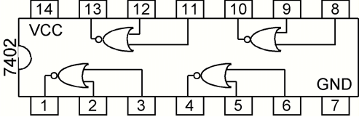
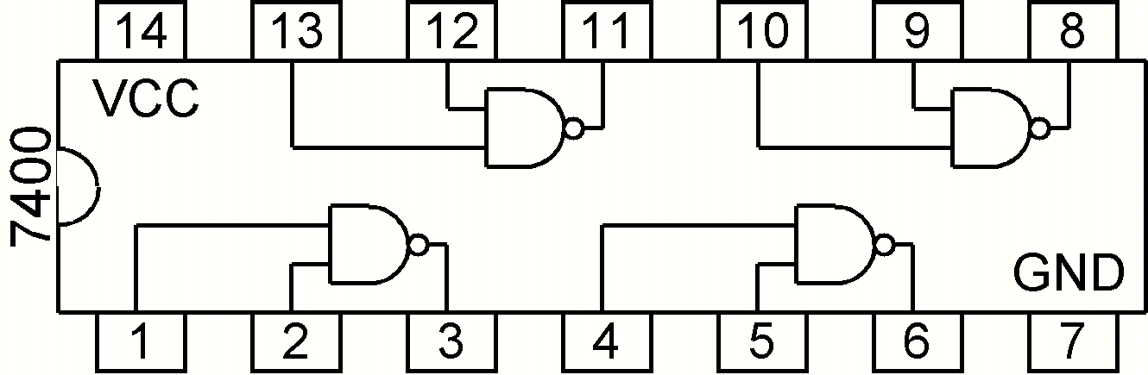

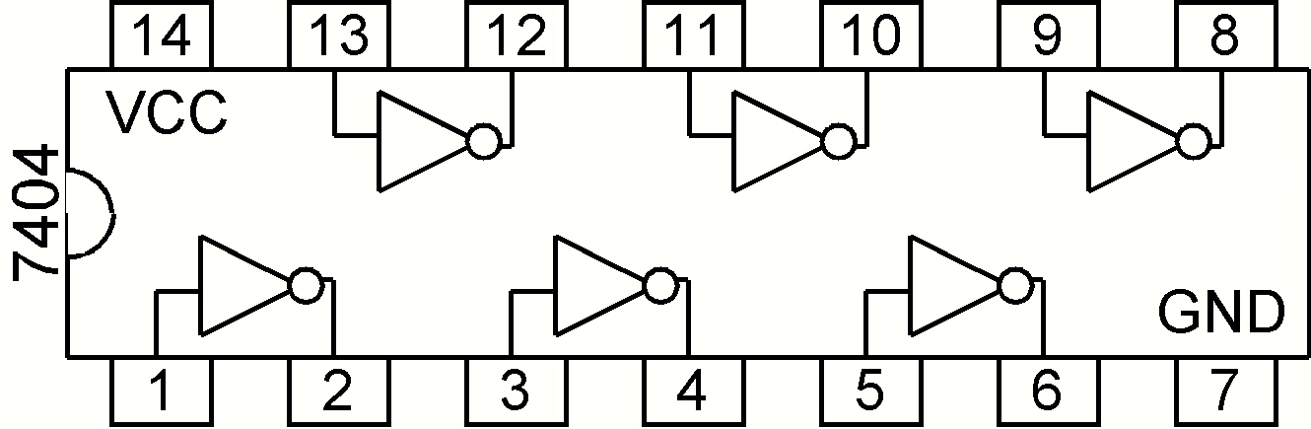
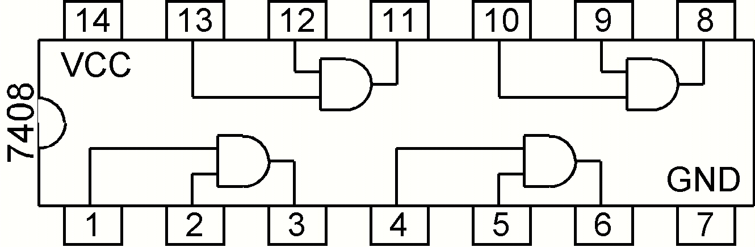

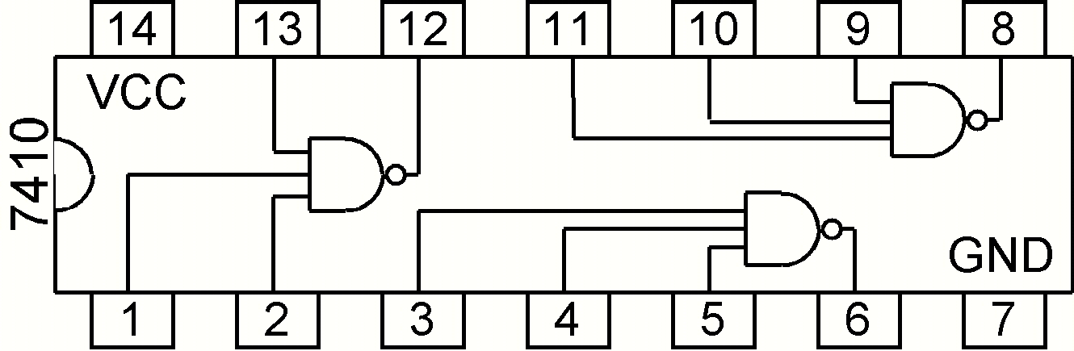
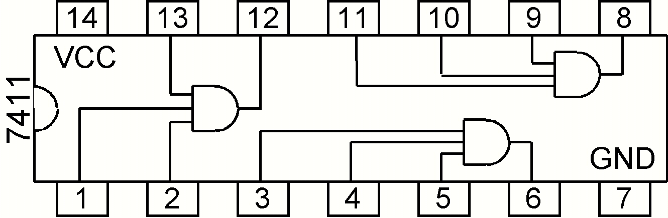

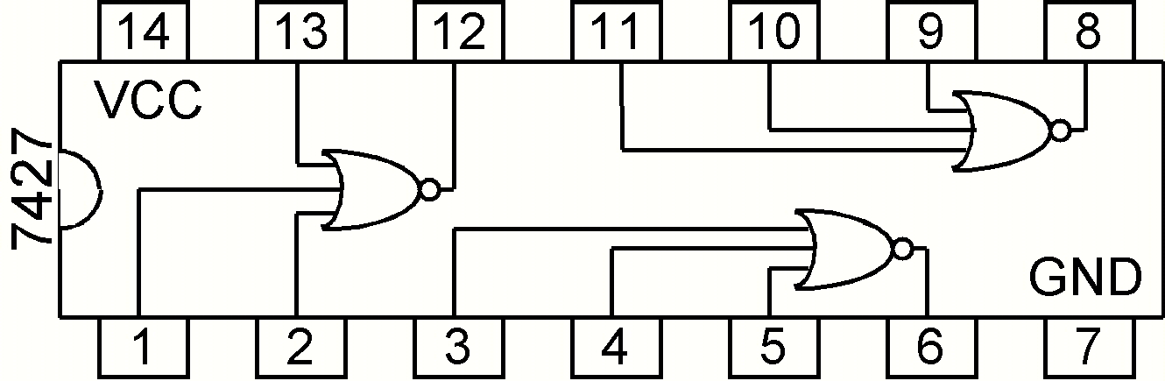
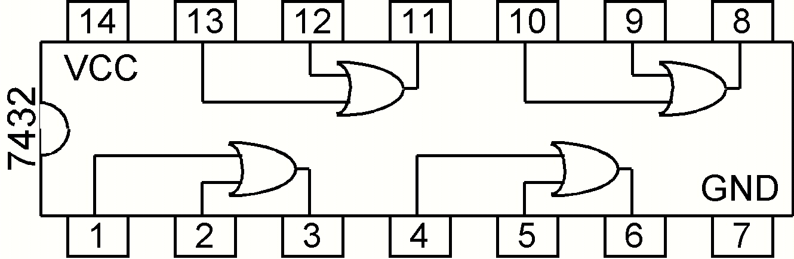
1) First, you must write out F(A,B,C) in standard SOP form and draw a circuit schematic. Then you can start the design by using the proper ICs as practiced in Lab 1. Be sure to show your TA your completed circuit before moving onto the next step. This goes for every circuit you will implement in this lab.

More than two-input OR gates can be created by using multiple two-input OR gates and connecting the output as the input for another two-input OR gate, as shown. Here, A, B, and C are inputs, and F is A + B + C.


A
F

B

C

2) Then you should write out F using only NAND gates and draw a schematic (it may be helpful to first draw the circuit using AND gates and OR gates). Then wire the circuit on the trainer board.

Please refer back to Lab 1 if you need any reminders on how to use the trainer board or the 7400-series ICs. The inputs of your circuit should be connected to the switches on the bottom left, and the output should go to the LEDs on the top right. Remember to only connect the chips to the +5V and GND connections.

You should include your SOP equation (1), your NAND only SOP equation (2), and all schematic drawings of each circuit in your report.

